How does OLIS achieve a single spectrophotometer which optimizes for CD, CPL, and anisotropy?

We call the answer our “Polarization Toolbox.”

The Polarization Toolbox is a sample compartment developed to allow immediate and fail-safe positioning of polarizer(s) and a modulator before or after the sample. Let’s call this positionable polarization hardware a “Polarization Modulator Assembly” or PMA.
If the PMA is before the sample, thereby polarizing the incoming light, the Toolbox is producing CD. If the PMA is after the sample, the polarized emission light is being detected for CPL and anisotropy.
This document focuses on the emission measurements.
With a vertically polarized excitation and where I‖ and I are the intensities of the vertically & horizontally polarized emission.
Fluorescence anisotropy (r) : r = (I‖ – I )/ (I‖ +2I)
Polarization of fluorescence (P): P = (I‖ – I )/ (I‖ +I)
The method for emission data collection is described in the 1974 Analytical Chemistry paper, “Recording polarization of fluorescence spectrometer: Unique application of piezoelectric birefringence modulation,” https://pubs.acs.org/doi/abs/10.1021/ac60340a004
DeSa realized that the use of “piezoelectric birefringence modulation” would eliminate the need for two detectors, rotation of polarizers at each, and the associated four G-factor corrections. His colleague and co-author, Wampler, wrote the math for this novel advance in polarization measurements.
With their ‘74 method, a single detector is used, no movement of the polarizer is needed, and no G-factor correction is required for anisotropy or CPL measurements.
The ‘74 Method simplifies the hardware, eliminates the analog element, and collects the desired data directly and thus perfectly.
Richard DeSa’s motto: Why do manually what can be done electronically? Electronically is failsafe, easy, perfect.
Very commonly, the modulator is a photoelastic modulator (PEM), as is used for circular dichroism. This 50 kHz modulation rate switches the L & R (or parallel and perpendicular) polarization 50,000 time per second. A PEM is always used for CD mode and anisotropy stopped-flow.
The same PMA can be moved at a 90-degree position and used for CPL. For CPL, we commonly choose a quarter waveplate instead of the PEM, because this frees data collection from the 50 kHz modulation rate. The freedom to collect Lum(L) and Lum(R) at slow speed has considerable advantages.
The following figures show PMA positioning for the measurements. The software does the rest:
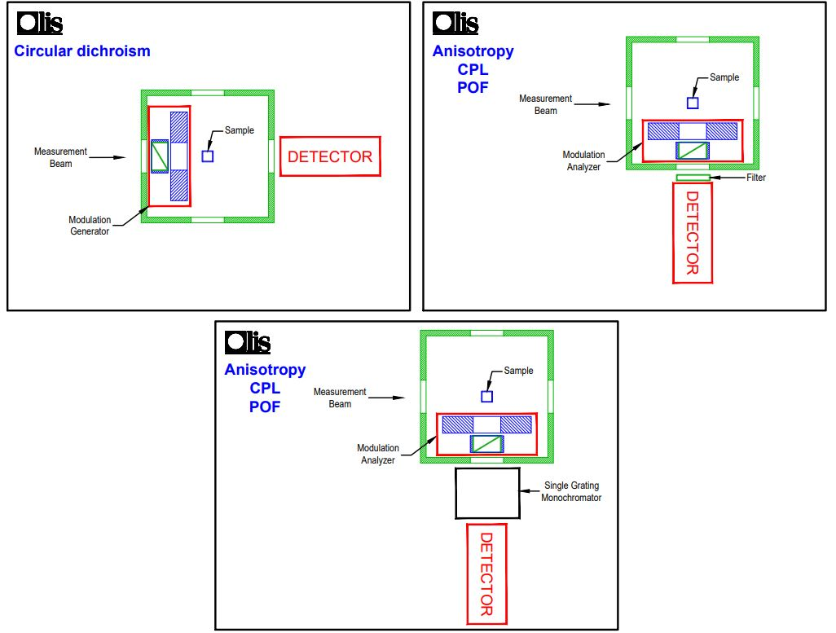

For Anisotropy, the excitation light (“measurement beam”) passes through a vertically oriented linear polarizer before striking the sample.
The light emitted by the sample is captured at 90-degrees after it passes through a fixed polarizer and either a filter (shown) or scanning monochromator, and then to the detector.
Unlike L-format polarization systems which other manufacturers are limited to -- in which the polarizer must be physically rotated between the vertical and horizontal positions – the DeSa-Wampler method is more direct, simple, and perfect.
DeSa’s utilization of a modulator – a 50 kHz photoelastic modular (PEM), liquid crystal variable retarder (LCVR), or waveplate -- rotates the plane of polarization of the emitted light rather than moving the polarizers.
One of the beneficial consequences is that no G-factor correction is needed to correct for the different intensity responses of the monochromators to the two states of polarization. The OLIS method has fixed, stationary polarizers.
In the case of the LCVR and waveplate, switching between L and R (or parallel and perpendicular) can be made at an arbitrary speed, liberating data collection from the 50 kHz rate of the PEM.
So, if the emission polarizer is fixed in the horizontal position, when the modulator is off, no rotation occurs and I_{v} can be measured. When the modulator is on, the plane of polarization is rotated 90 degrees and what was horizontal is now vertical. This passes through the horizontally oriented polarizer.
Detection is handled by the exquisitely sensitive gated photon counting PMT for maximum sensitivity.
By synchronizing the detection with the modulator, the appropriate Ivv and Ivh values can be obtained and used to calculate anisotropy or CPL.
Because the polarization state of detected light is always horizontal, there is no effect of polarization (including Wood’s anomalies in the monochromator) on the intensity. No G-factor correction is required. There are no moving parts; neither polarizer is rotated.
The following figure shows an example of a dilute fluorescein solution in glycerol. The temperature was increased from 20°C to 80ºC as measured in a Peltier temperature-controlled cell. The recorded polarization decreases as a function of temperature, reflecting the increased motion of the fluorescein molecule.
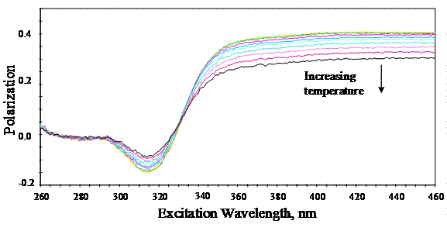
The choice of the modulator -- PEM, LCVR, or waveplate -- should be based on two aspects of the measurement. The first is the switching rate required. Applications such as stopped flow and CD, which require rapid switching, require the PEM. Slower anisotropy and all CPL measurements can be done with the PEM, LCVR, or waveplate.
In addition to speed of modulation, one must also consider the wavelength range required. The respective spectral ranges are 170 nm – 1400 nm for the PEM, 340 nm -2000 nm for the LCVR, and 270-2000 nm for the waveplate.
One moves between anisotropy and by switching the modulation rate in the software; hardware remains unchanged

Circularly polarized luminescence (CPL) is the differential emission of left and right circularly polarized light from a chiral fluorophore. CPL is extremely sensitive to the environment of the excited state. CPL has been used to characterize transition metal ligand complexes (a signal is seen only when coordinated to a chiral ligand), trivalent lanthanide complexes, and chiral lactones. In addition, bio macromolecular molecules have been probed by using Tb3+[ref], dansyl, acridine, and intrinsic tryptophan. These probes, particularly tryptophan, are sensitive to tertiary structure.
The units for CPL are G_{(LUM)}, where
G_{(LUM)} = 2 [(I_{L}-I_{R})/I_{L}+I_{R})]

Interesting fact: Unfolded proteins, exhibit zero CPL signal.

The CPL spectrum of Europium(III) tris[3-(trifluoromethylhydroxymethylene)-d-camphorate in DMSO.
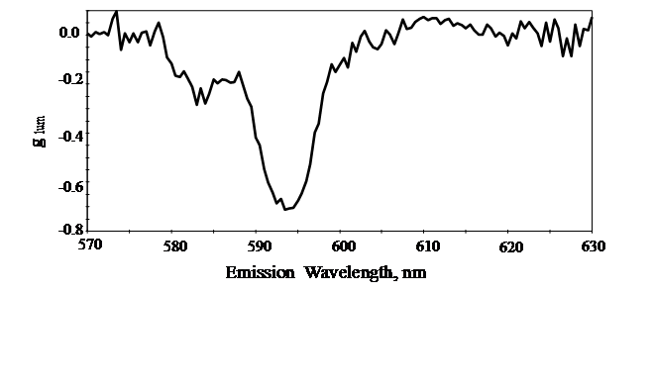
The Polarization Toolbox is a self-contained sample compartment which we offer on three OLIS instruments:
- The CPL Solo is the Polarization Toolbox, emission monochromator and emission detector, and one or more LEDs.
- The OLIS DSM 172 is the Polarization Toolbox, double prism-grating monochromator, emission monochromator, 150-watt xenon arc lamp, and detectors for both CD (PMT) and CPL (photon counting PMT). This model has both UV/Vis and NIR: CD is 185-1700 nm and CPL is 230-850 nm.
- The OLIS DSM 245 is the Polarization Toolbox, double grating monochromator, emission monochromator, 150-watt xenon arc lamp, and detectors for both CD (PMT) and CPL (photon counting PMT). This model supports 170-700 nm for CD and 230-850 nm for CPL.

References
Recording Polarization of Fluorescence Spectrometer -- A Unique Application of Piezoelectric Birefringence Modulation
John E. Wampler and Richard J. DeSa, Analytical Chemistry, 46,563 (1974)
Modulator polarization technique:
Wampler, J. E. and DeSa, R. J. (1974) Anal. Chem. 46, 563.
Older, but good review of CPL:
Richardson, F. S. and Riehl (1977) Chemical Reviews 6, 773-792.

A G-factor is the correction to the effect of the inherent bias of monochromators to the orientation of a polarizer. Every monochromator has some polarization bias. This bias causes changes in the transmitted intensities between the two orientations of the polarizer. When a measurement requires a change in the orientation of the polarizer, a correction factor must be applied to cancel this effect, i.e., the G-factor correction.
Strangely, Jasco returns CPL as “mdegs,” which is utterly incorrect. Millidegrees is the unit used for circular dichroism, the absorbance analogue to CPL.

